Account Expiration Notification using Power Automate

Purpose –

Sometimes To send out account expiration notifications to contractor

.

Plan –

To create these alerts, we use a flow in Power Automate,

Flow is set up our service account, [###-FlowAdmin@######.onmicrosoft.com](mailto:###-FlowAdmin@######.onmicrosoft.com)

Password - ########

The HTTP function we use in Power Automate is a premium feature

Let’s get start it –

Create the flow -

We can now go on and create a flow. Head over to your [Power Automate portal](https://flow.microsoft.com/), and start with an empty flow. Pick the scheduled flow to run this daily or weekly, depending on your needs. In our case let’s take it weekly.

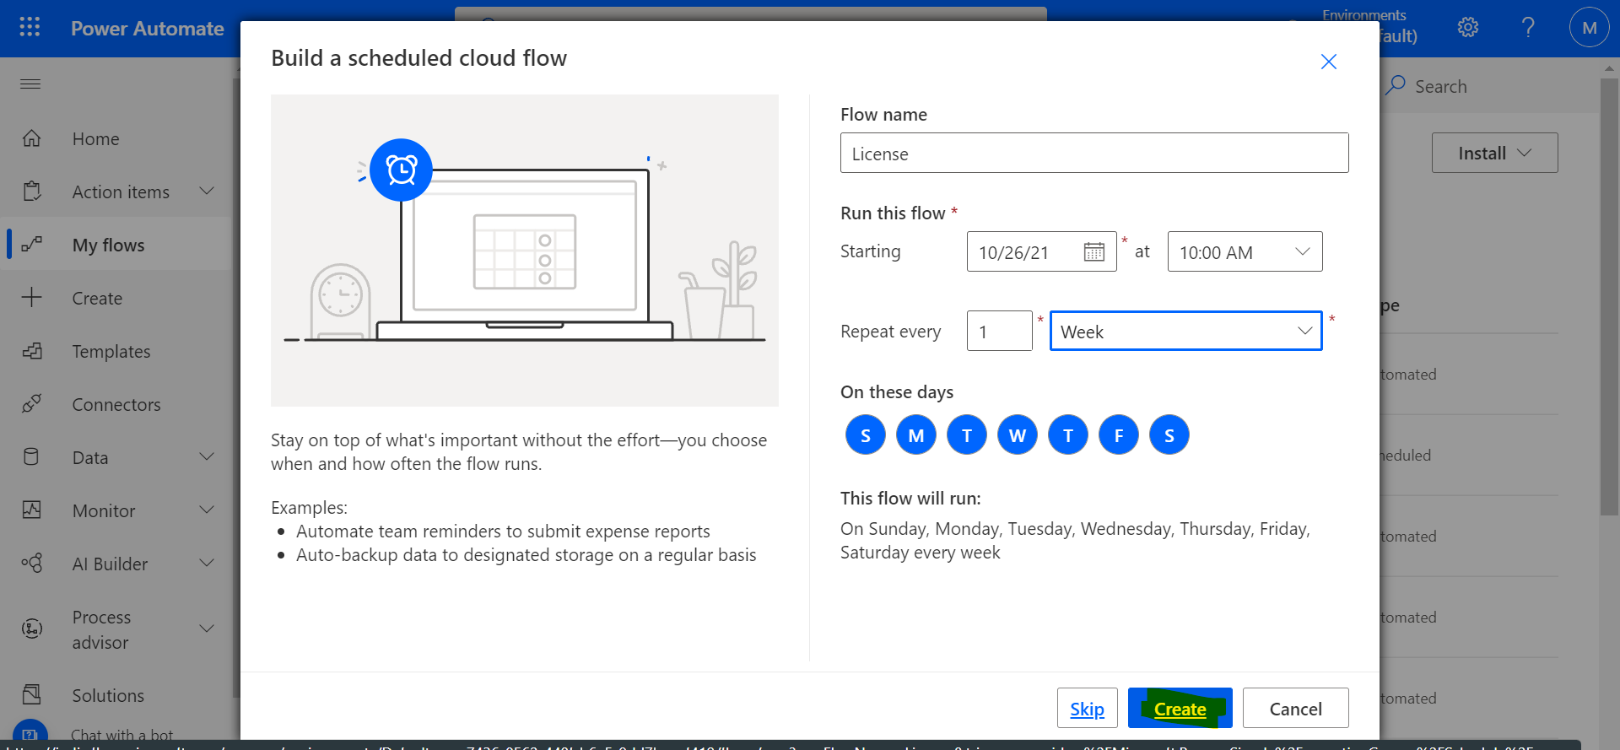

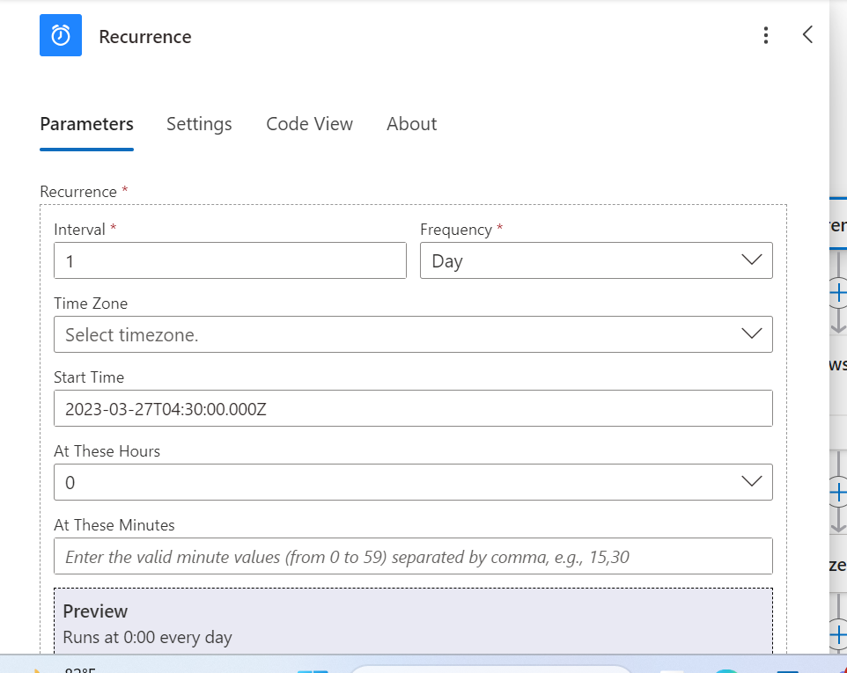

In our next step, we are importing contractor details through file

Next, we are going to initialize two variables.

In the next step, create an*Apply to each* action and set the variables according to the figure below.

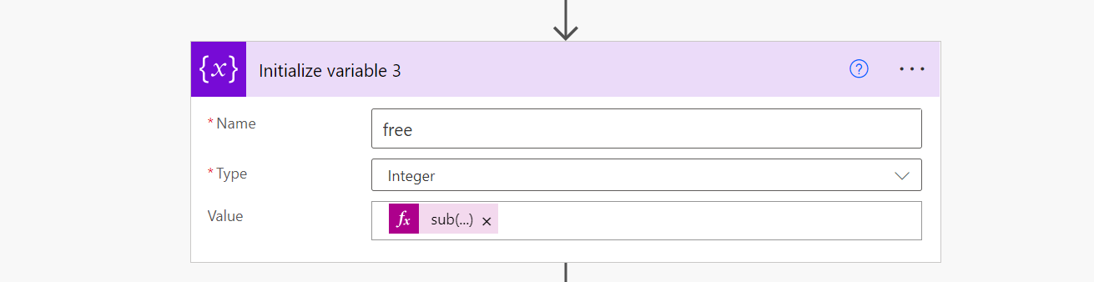

Next, we can use conditions to check if extension attribute value is equal and less than 20 days send an email if it is true.

